**Access Step-by-Step Guide**

Open Access 2007/2013 version on your computer.

If you have a previous database open it and proceed to phase 2. If not, follow the next steps.

Select blank desktop database.

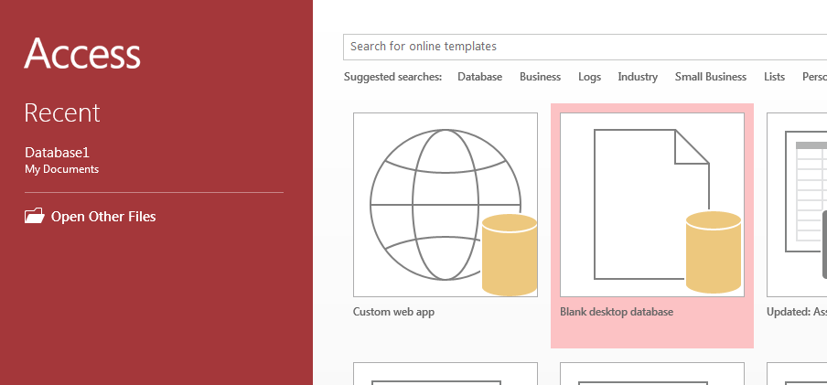

The following window will pop up. Create your own file name, choose where you want to save it by clicking the folder icon and click create.

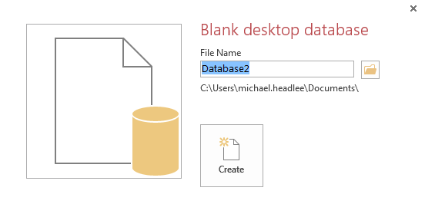

If you have not established a link to the external database, proceed to phase 1. If you have proceed to phase 2.

**Phase 1: Establishing the link with an external database**

Open Access 2007/2013 version on your computer.

Go to the *external* tab on the top left of the database.

Click on the *ODBC Database.*

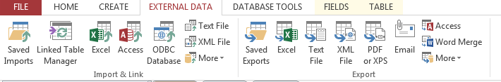

This will bring up the following screen:

Select the *Link to the data source* option and press OK.

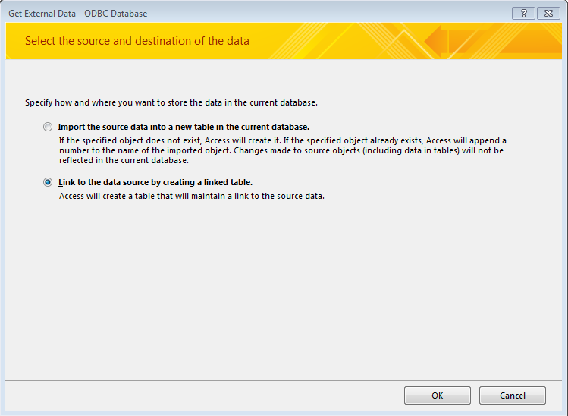

Click on the *Machine Data Source* tab and select *New*.

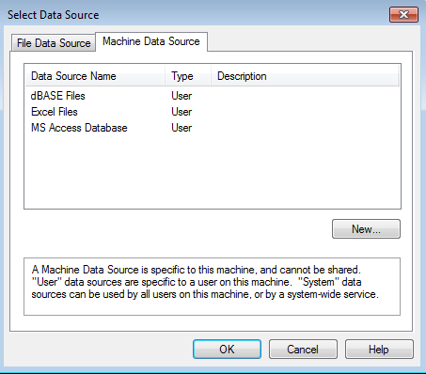

This will bring up the following screen (just press ok):

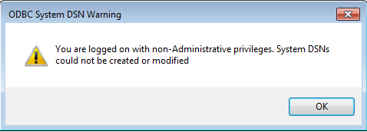

Select *User Data Source* and press Next.

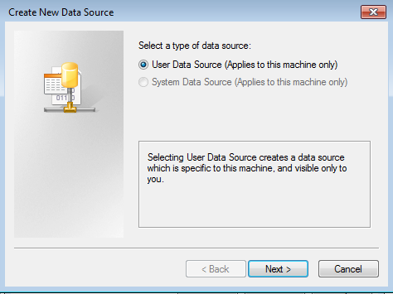

Locate the *SQL Server* source, select it and press Next.

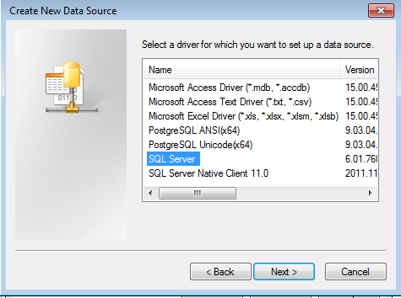

This will display the following screen which you will click finish.

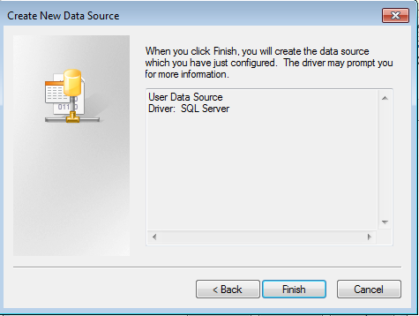

You will then create the ODBC data source to connect to the SQL Server.

**Enter database specific information**

Copy the Name, Description and SQL server text stated below:

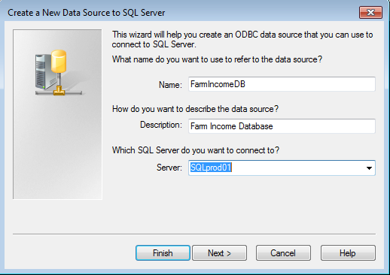

Verify you have the same information selected in the 3 following images:

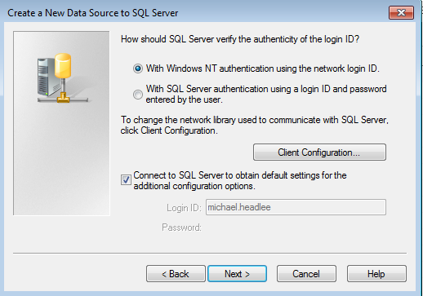

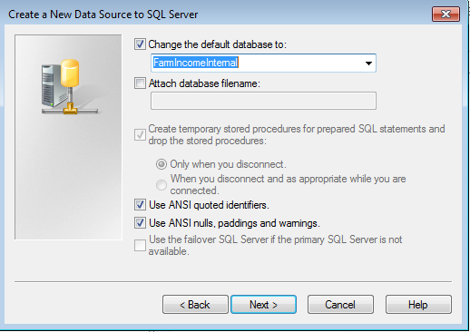

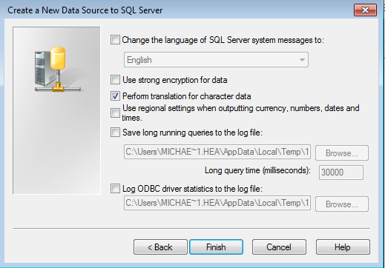

After you click finish, the server setup box will appear. Click on *test data source* to verify that the ODBC data source works.

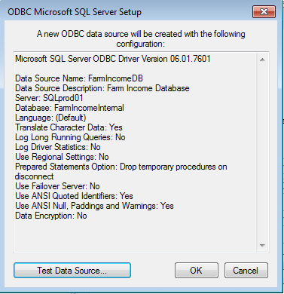

Once you test your source, you should receive successful test results. Click the okay box and the external data should work after.

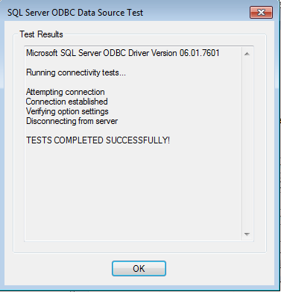

**Phase 2: Set up Tables and Queries**

Right click on the table1 (default table when you create a new database), and choose import and pick ODBC Database.

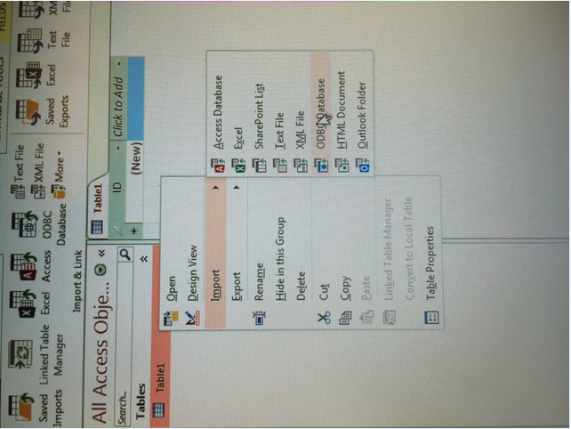

This window will open and then choose the *link to the data source* option.



You should see the name you gave for the database link from phase 1.

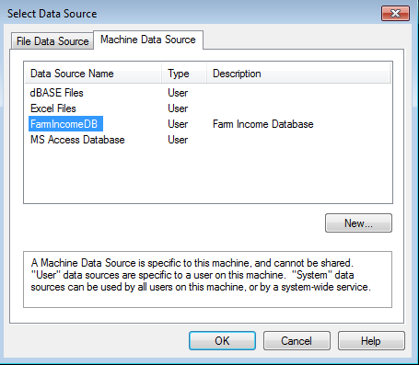

Click on the *Machine Data Source* tab.



You should see the name you gave for the database link from phase 1.



Once you click OK, the following with a list of tables will appear. Choose the one you want to link to and press OK. We will be using ERS_wide_access.public_data for the first couple classes.

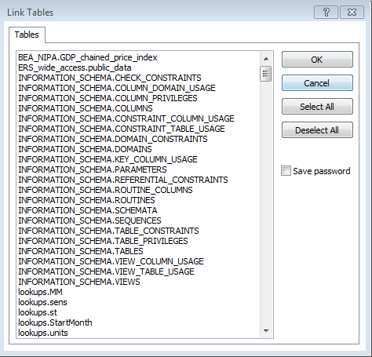

Linking is complete and the link table will appear.

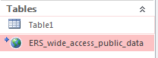

If you right click and choose open, the data will appear.

**Phase 3: Making a Query**

Click on the create tab and click the query design button.

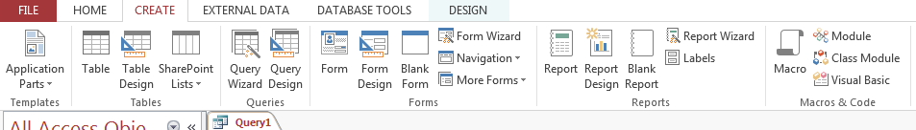

This table will appear, and you can click close.

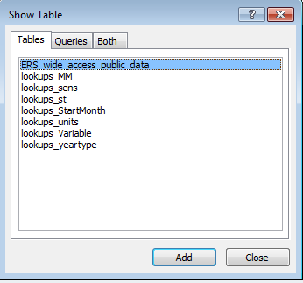

Right click and choose SQL view on the query tab.

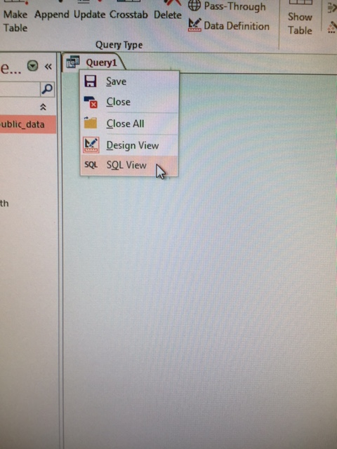

The query will now show where to write your SQL code.

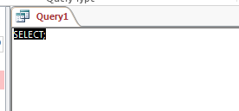

Write your code, then right click the query tab and choose design view to see the results.

